**Summary**: in this tutorial, you will learn how to create a new database in SQL Server and execute the script to load the sample database.

First, you need to download the following zip file if you have not done so:

Second, uncompress the zip file, you will see three SQL script files:

* BikeStores Sample Database - create objects.sql – this file is for creating database objects including schemas and tables.
* BikeStores Sample Database - load data.sql – this file is for inserting data into the tables
* BikeStores Sample Database - drop all objects.sql – this file is for removing the tables and their schemas from the sample database. It is useful when you want to refresh the sample database.

Third, let’s create a database, create the schemas and tables, and load the sample data.

Step 1

Connect to the SQL Server by (1) choosing the server name, (2) enter the user and (3) password and (4) click the **Connect** button.

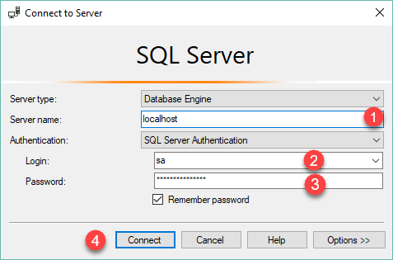

Step 2

Right-click the **Databases** node in the **Object Explorer** and select the **New Database…** menu item

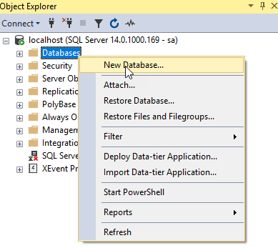

Step 3

(1) Enter the **Database name**as BikeStores and (2) click the **OK** button to create the new database.

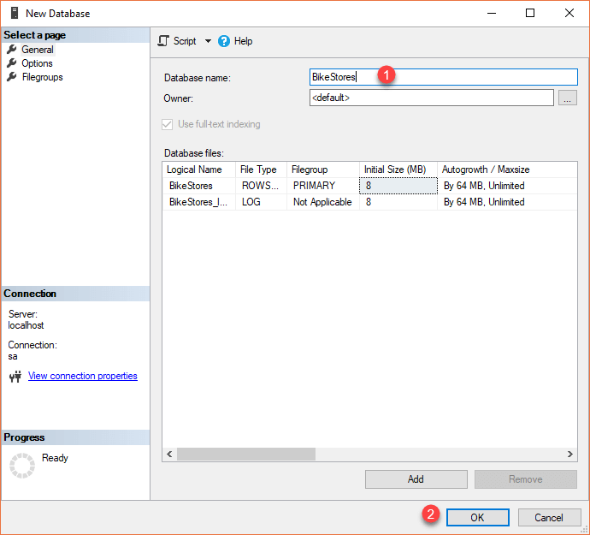

Step 4

If everything is fine, you will see the database **BikeStores** appears under Databases node as shown in the screenshot below:

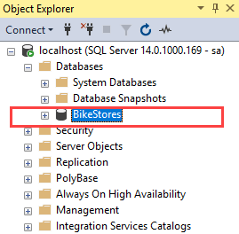

Step 5

From the File menu, choose Open > File… menu item to open a script file.

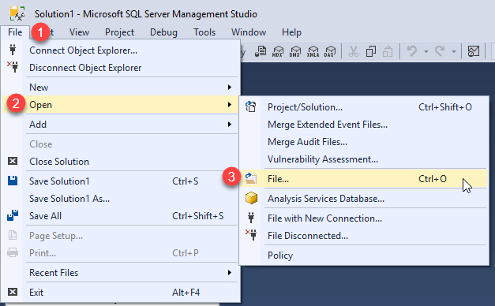

Step 6

Select the **BikeStores Sample Database – create**objects.sql file and click the Open button

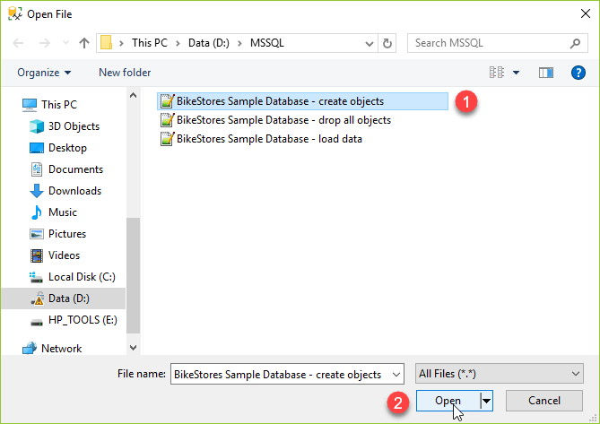

Step 7

Click the **Execute** button to execute the SQL script.

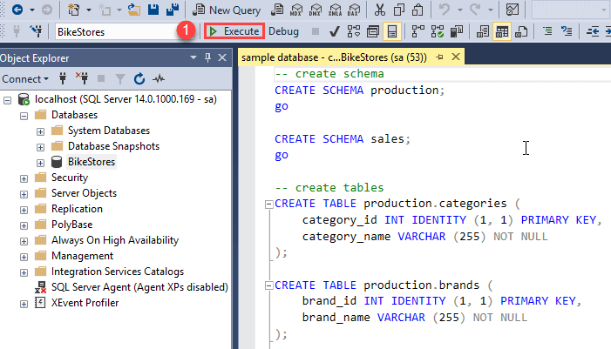

You should see the following result indicated that the query executed successfully.

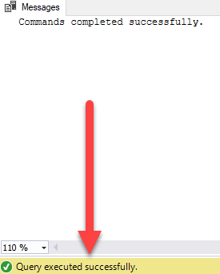

If you expand the **BikeStores > Tables**, you will see the schemas and their tables are created as shown below:

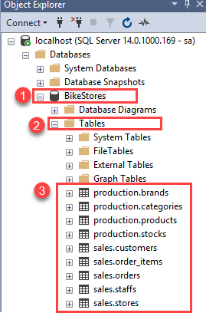

Step 8

Open the file for loading data into the tables.



Step 9

Choose the **BikeStores Sample Database – load data.sql** file and click the Open button.

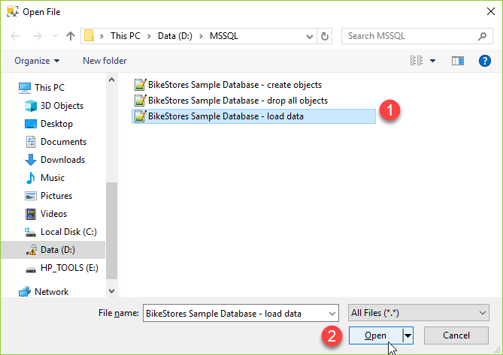

Step 10

Click the **Execute** button to load data into the tables.

You should see the following message indicating that all the statements in the script were executed successfully.

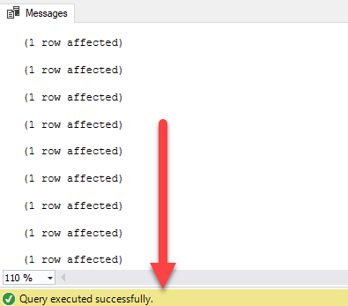

In this tutorial, you have learned how to load the BikeStores sample database into the SQL Server.